The client notified me that his current signature has stopped working , now when he sends an email the signature is all empty as shown below

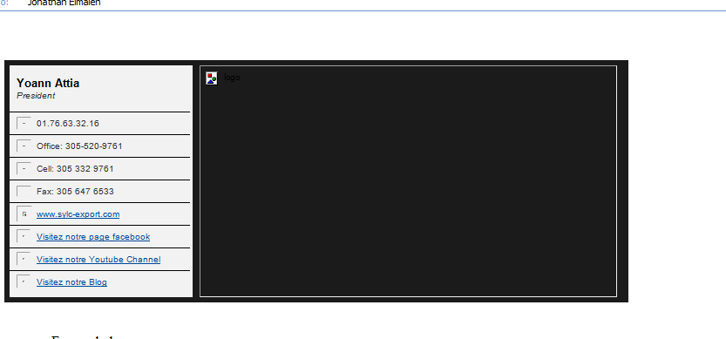

Please make sure that this has been fixed. also if changes has been made please provide the new signature